Visual Basic Screenshots #10 – String Manipulation - Tom H

1. The string variable types come with a lot of inbuilt power. Strings have their own properties and methods, just like a textbox or label or form does. That's because strings are objects. (In fact, all variables are objects in VB.NET, including the number variables.) In a later section, we'll be going into a bit more detail on objects. For now, think of them as things that can be manipulate.
2. The trim method: What this does is to trim any leading or trailing blank spaces from a string. So if the string was "Text", then Trim would delete those spaces for you, leaving just "Text".
3. If someone sets the value that may have numbers that you don’t want in it you can use the ‘Chars’ property. Char is a variable type: “Dim OneCharacter As Chars.”
4. 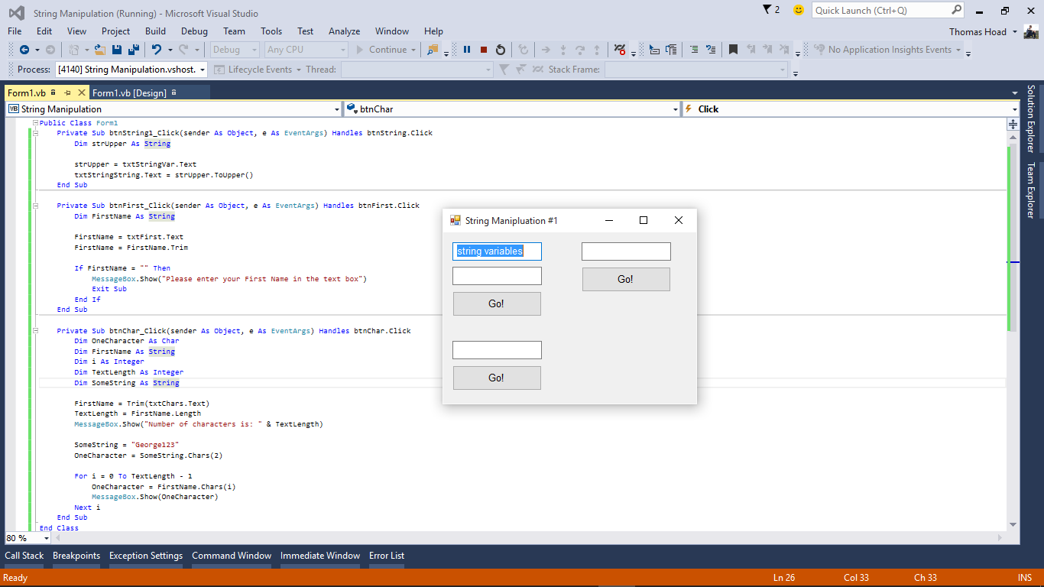Chars is a method of the String variable type. You can use it on any length of string, not just a Char variable. And that's the difference between the two: Char is a variable type, while Chars is a method you can use on Strings.